ST. PATRICK KIGULU GIRLS’ BOARDING PRIMARY SCHOOL
REVISION TEST 2020
P.5 – Integrated Science

Name: ________________________________ Stream: ____________

SECTION A
- What do plants use for breathing?
__________________________________________________________________________
- How is a cat useful at home?
________________________________________________________________________
- Identify the use of a trowel to farmers.
________________________________________________________________________
- Write down one example of an intestinal worm.
________________________________________________________________________
- Give one example of a plant with tap root system.
_______________________________________________________________________
- Mention onereason why we eat food.
_______________________________________________________________________
- Name the instrument used to measure temperature.
_________________________________________________________________________
- Below is an example of a pest, name it.
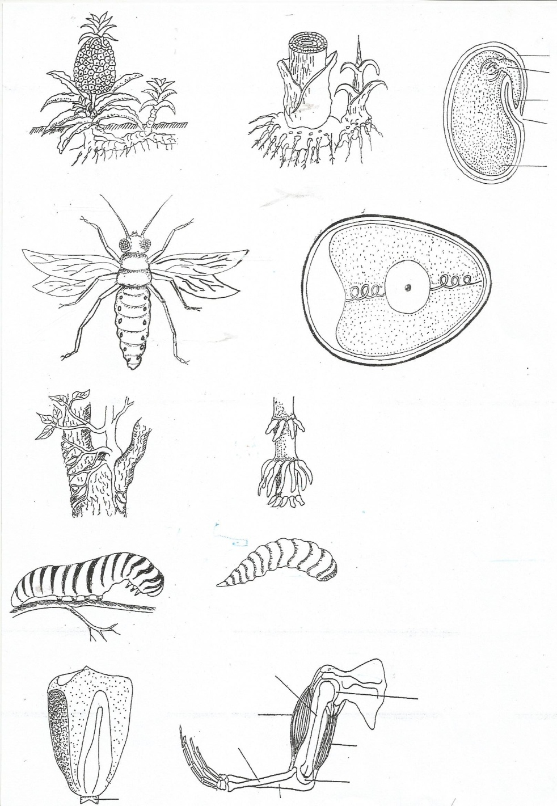
_______________________________________________________________________
- Mention one danger that can result from playing in dirty places.
_______________________________________________________________________
- Which part of a seedgrows into shoot system?
_______________________________________________________________________
- A part from protection against enemies. State another reason why a chameleon changes colour. ___________________________________________________________________________

- Why is it good to keep our classrooms clean?
_______________________________________________________________________
- Which part of body is used for feeling?
__________________________________________________________________________
- State any one way of preventing tape worms
________________________________________________________________________
- Why is it advisable to keep finger nails short?
__________________________________________________________________________
- Name the use of nimbus clouds in the sky.
___________________________________________________________________________
- State oneadvantage of mulching soil.
__________________________________________________________________________
- Which type of fracture is shown in the diagram below?
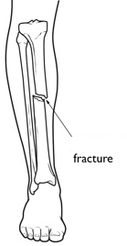_________________________________________________
- Identify the first aid you can give to someone with such a fracture.
________________________________________________________________________
- Which stage of a housefly is dangerous to people?
___________________________________________________________________________
- Give any one example of crop grown for food in our environment.
__________________________________________________________________________
- What are annual crops?
________________________________________________________________________
- Mention one tool used in weeding gardens
_______________________________________________________________________
- Give one danger of too much rainfall in environment.
______________________________________________________________________
- Apart from brushing, name any other method of caring for teeth.
___________________________________________________________________________
- Name the type of weather which favours planting of crops.
_________________________________________________________________________
- How can we keep food free from germs?
___________________________________________________________________________
- Which part of flower develops into seeds?
___________________________________________________________________________
- Which organ of the body is responsible for thinking and reasoning?
________________________________________________________________________
- Name the type of food made through photosynthesis.
_______________________________________________________________________
- Why are we always advised to sleep under treated mosquito net?
___________________________________________________________________________
- Write one method of keeping water safe for drinking
___________________________________________________________________________
- Name one activity done to care for crops in gardens.
___________________________________________________________________________
- Which type of family has father, mother, children and relatives?
_________________________________________________________________________
- Which vector spreads Diarrhoea?
___________________________________________________________________________
- Give one use of leaves to plants.
_________________________________________________________________________
- Which part of fish helps it to detect danger in water?
___________________________________________________________________________
- Why do bees visit flowers?
________________________________________________________________________
- Mention the use of water at home.
___________________________________________________________________________

- State one property of air.
__________________________________________________________________________
SECTION B
- Study the diagram below and answer the questions that follow.
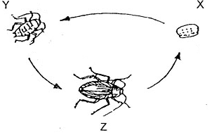
(a) Why is the above type of metamorphosis said to be incomplete?
________________________________________________________________________
(b) Name the stages marked Y and Z
(i) Y______________________________(ii) Z____________________________________
(c) Which structures are contained in stage marked X?
______________________________________________________________________________
42. (a) Explain the term personal hygiene.
__________________________________________________________________________
(b) Give any two ways of keeping personal hygiene.
(i) __________________________________________________________________________
(ii) __________________________________________________________________________
(c) Write down one use of keeping hair short.
__________________________________________________________________________
43. (a) What name is given to the disease-causing micro-organisms?
____________________________________________________________________________
(b) Mention two of the above mentioned micro-organisms.
(i) __________________________________ (ii)__________________________________
(c) Give one way through which we can prevent dangers caused by such micro-organisms
___________________________________________________________________________
44. (a) Define the term Pollination.
_____________________________________________________________________________
(b) State twoagents of pollination.
(i) ___________________________________________________________________________
(ii) ________________________________________________________________________
(c) Give one characteristic of insect pollinated flowers
_________________________________________________________________________
45.Fill in the table below with correct example of crop under each type
Vegetable | Fruit | Cereal | Legume
____________ | _____________ | _______________ | _________________

46. Use the diagram below to answer questions that follow
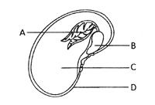
- Name the parts labeled C and D.
(i) C______________________________ (ii) D_____________________________
- Where does part A and B get their food during germination?
_____________________________________________________________________
- Define the term germination.
______________________________________________________________________
47. (a) Define kindling in rabbit keeping.
___________________________________________________________________________
(b) Write down two examples of exotic breeds of rabbits.
(i)_________________________________________________________________________
(ii) ____________________________________________________________________
- Why do most farmers prefer keeping rabbits to other animals like cows?
___________________________________________________________________

48. Below is a diagram of tooth. Use it to answer questions that follow
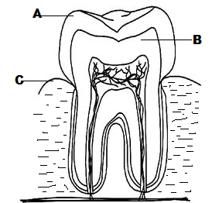
- Name the parts marked A,B and C.
(i)A________________________ (ii) B____________________
- Write down the name of the above shown type of tooth.
______________________________________________________________________
(c) Mention one set of teeth
______________________________________________________________________________
49 .Match the items in group A to those in B correctly
A B
Trowel used to carry manure, tools or harvested crops
Watering can used for transplanting.
Sickle used for watering crops
Wheel barrow used for slashing or harvesting cereals

50. Study the diagram of a flower below and answer questions which follow.
R
T
S

V

U
- Name parts marked;
- R __________________________ (ii) U______________________________
- Which part marked on the diagram protects delicate inner parts?
________________________________________________________________________
- Which type of pollination is likely to take place in the flower shown above?
__________________________________________________________________________
51. (a) Define the term sanitation?
______________________________________________________________________________________________________________________________________________________
(b) Identify two ways in which a community can promote sanitation.
(i) ______________________________________________________________________
(ii) _____________________________________________________________________
(c) Mention one danger that results from poor sanitation.
________________________________________________________________________
52. a) Name two crop pests you know.
i) ____________________________________________________________
ii) ___________________________________________________________
b) Give any two methods of controlling pests in gardens.
i) __________________________________________________________
ii) ______________________________________________________________
53.(a) State any two conditions of weather.
(i)_____________________________________________________________________
(ii)____________________________________________________________________
(b) Give the uses of the following weather instruments;
- Barometer _____________________________________________________________
- Rain gauge____________________________________________________________
54. (a) Define the term Balanced diet.
_____________________________________________________________________________
(b) Identify one class of food that is part of balanced diet.
___________________________________________________________________________
(c) State the main cause of Kwashiorkor.
_________________________________________________________________________
(d) Mention one example of food stuff rich in vitamins.
_____________________________________________________________________________
55.(a) Define the term accident.
________________________________________________________________________
(b) Suggest one cause of accidents on roads.
______________________________________________________________________
(c) State one way of preventing accidents on roads.
______________________________________________________________________
(d) Mention one road user that can get involved in road accidents.
____________________________________________________________________

